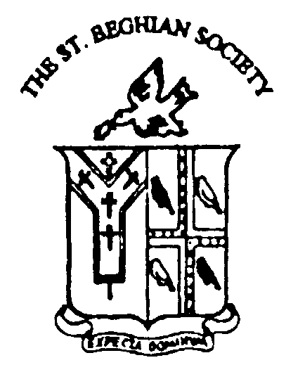

OLD ST. BEGHIANS’ DAY
2010

Saturday, 18th September

Please see the front of the Bulletin for a full timetable of events for the day.

A Buffet Lunch will be available in the Whitelaw Building
at 1.00 p.m. price £15.00 per person (inclusive of wine).
Please see booking form below.

The Head's Reception of Afternoon Tea and a Bar will be held this year due to the Autumn Ball in the Whitelaw Building from 4.00pm.

Please complete the booking form below and return together with your
cheque made payable to The St. Beghian Society, to:

The Secretary
The St. Beghian Society
St. Bees School
St. Bees
Cumbria. CA27 0DS

I intend / do not intend to be present on St. Beghians’ Day.

I wish to reserve ………. places for lunch at £15.00 per person.

The number in my party for tea will be ……….

Name ………………………………………………………………………..

House and years …………………………………………………………….

I enclose my cheque to the value of £……………. P.T.O.
SPORT:

I should like to play for the Old St. Beghians on the 18th September, 2010 at:
a) Rugby
b) Hockey
c) Squash
d) Fives
e) Other (Please specify)

If you have indicated above that you would like to be involved in a sports activity during St. Beghians’ Day, please contact one of the people listed in the Bulletin directly on the relevant phone number.

News for The Old St. Beghian Bulletin.
Please let us have any news of either yourself or any member of the Society known to you.

Change of address or update of any other details.
Please let us know of any applicable changes.

